**CSA05: DATABASE MANAGEMENT SYSTEMS-ASSIGNMENT-3**

**Name : K.SRIKESH**

**Reg no. :192321040**

**Question 1: Handling Division Operation**

**Task:**

* + - 1. Write a PL/SQL block to perform a division operation where the divisor is obtained from user input. Handle the ZERO_DIVIDE exception gracefully with an appropriate error message.

**Deliverables:**

* + - 1. PL/SQL block that performs the division operation and handles exceptions.
      2. Explanation of error handling strategies implemented.

**PL/SQL**

BEGIN

DECLARE

v_dividend NUMBER := 100;

v_divisor NUMBER := :P1_DIVISOR;

v_result NUMBER;

BEGIN

v_result := v_dividend / v_divisor;

DBMS_OUTPUT.PUT_LINE('Result: ' || v_result);

EXCEPTION

WHEN ZERO_DIVIDE THEN

DBMS_OUTPUT.PUT_LINE('Error: Division by zero is not allowed.');

  END;

END;

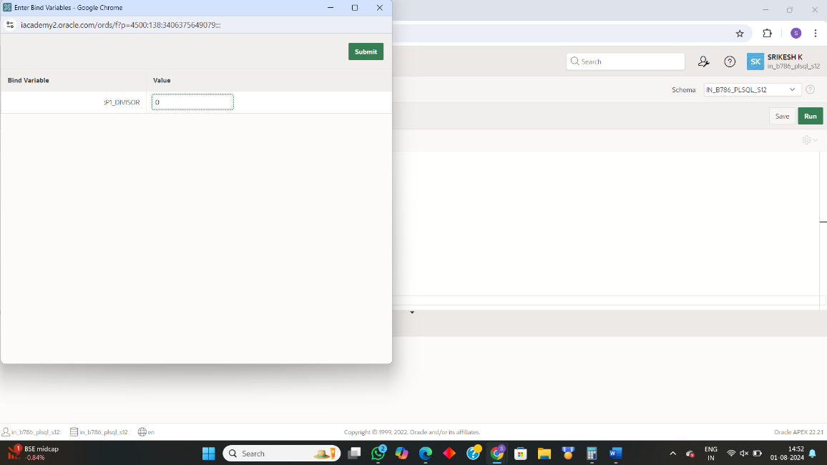

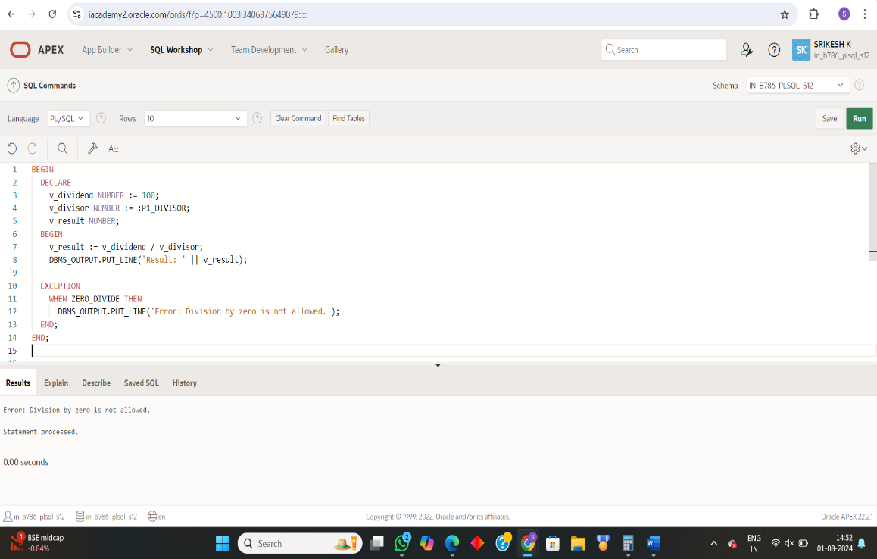

EXPLANATION :

• **Outer BEGIN ... END; Block**: Encloses the entire PL/SQL code, marking the start and end of the executable section.

• **DECLARE Section**:

* v_dividend initialized to 100.
* v_divisor assigned the value of the APEX page item P1_DIVISOR.
* v_result declared to store the division result.

• **Inner BEGIN ... END; Block**:

* Performs the division operation v_result := v_dividend / v_divisor;.
* Outputs the result using DBMS_OUTPUT.PUT_LINE('Result: ' || v_result);.

• **Exception Handling**:

* EXCEPTION section catches the ZERO_DIVIDE exception.
* Outputs error message "Error: Division by zero is not allowed." if division by zero occurs.

• **Purpose**: Handles runtime errors gracefully, using APEX page items for input and bind variables to integrate user values.

**Question 2: Updating Rows with FORALL**

**Task:**

1. Use the FORALL statement to update multiple rows in the Employees table based on arrays of employee IDs and salary increments.

**Deliverables:**

* + - 1. PL/SQL block that uses FORALL to update salaries efficiently.
      2. Description of how FORALL improves performance for bulk updates.

**PL/SQL**

CREATE TABLE employees_update ( employee_id NUMBER PRIMARY KEY, salary NUMBER );

INSERT INTO employees_update (employee_id, salary) VALUES (1001, 3000);

INSERT INTO employees_update (employee_id, salary) VALUES (1002, 4000);

INSERT INTO employees_update (employee_id, salary) VALUES (1003, 5000);

DECLARE

TYPE emp_id_array IS TABLE OF NUMBER;

TYPE salary_inc_array IS TABLE OF NUMBER;

v_emp_ids emp_id_array := emp_id_array(1001, 1002, 1003); -- Example employee IDs

v_salary_incs salary_inc_array := salary_inc_array(500, 1000, 1500); -- Corresponding salary increments

BEGIN

-- Use FORALL to update the salaries

FORALL i IN INDICES OF v_emp_ids

UPDATE employees_update

SET salary = salary + v_salary_incs(i)

WHERE employee_id = v_emp_ids(i);

-- Commit the transaction

COMMIT;

END;

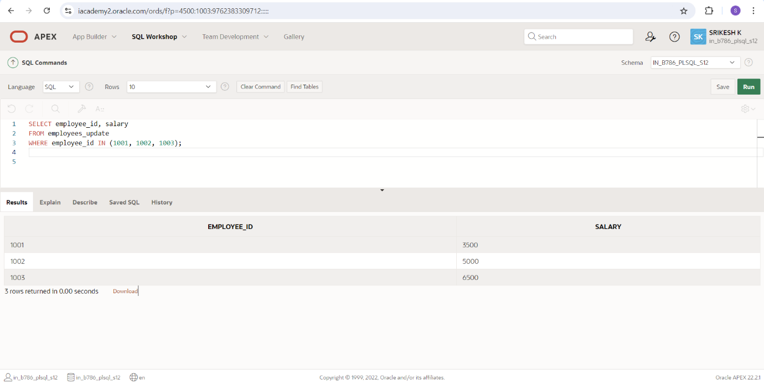

**Explanation:**

* **DECLARE Section:**
  + **Collection Types:**
    - Defines emp_id_array and salary_inc_array to hold employee IDs and salary increments.
  + **Initialize Collections:**
    - v_emp_ids with IDs (1001, 1002, 1003).
    - v_salary_incs with increments (500, 1000, 1500).
* **Outer BEGIN ... END; Block:**
  + Encloses the entire PL/SQL code.
* **FORALL Statement:**
  + **Bulk Update:**
    - FORALL i IN INDICES OF v_emp_ids
    - Updates salary by adding v_salary_incs(i) where employee_id = v_emp_ids(i).
* **COMMIT Statement:**
  + Saves the changes to the database.
* **Purpose:**
  + **Efficient Bulk Updates:**
    - Improves performance by reducing context switches.
    - Optimizes CPU and memory usage.
    - Enhances scalability for large data sets.

**Question 3: Implementing Nested Table Procedure**

**Task:**

* + - 1. Implement a PL/SQL procedure that accepts a department ID as input, retrieves employees belonging to the department, stores them in a nested table type, and returns this collection as an output parameter.

**Deliverables:**

1. PL/SQL procedure with nested table implementation.

Explanation of how nested tables are utilized and returned as output.

**PL/SQL**

**Create a Nested Table Type**

CREATE OR REPLACE TYPE emp_obj AS OBJECT (

emp_id NUMBER,

emp_name VARCHAR2(100),

emp_salary NUMBER

);

-- Create a nested table type to hold the employee objects

CREATE OR REPLACE TYPE emp_ntt AS TABLE OF emp_obj;

**Create the PL/SQL Procedure**

CREATE OR REPLACE PROCEDURE get_employees_by_dept(

p_dept_id IN NUMBER,

p_employees OUT emp_ntt

) AS

BEGIN

-- Initialize the nested table

p_employees := emp_ntt();

-- Retrieve the employees belonging to the specified department

SELECT emp_obj(emp_id, emp_name, emp_salary)

BULK COLLECT INTO p_employees

FROM employees

WHERE department_id = p_dept_id;

-- If no employees found, return an empty nested table

IF p_employees.COUNT = 0 THEN

p_employees := emp_ntt();

END IF;

END;

**Example Usage**

DECLARE

l_dept_id NUMBER := 10; -- Example department ID

l_employees emp_ntt;

BEGIN

get_employees_by_dept(p_dept_id => l_dept_id, p_employees => l_employees);

-- Display the employees

FOR i IN 1 .. l_employees.COUNT LOOP

DBMS_OUTPUT.PUT_LINE('Emp ID: ' || l_employees(i).emp_id ||

', Name: ' || l_employees(i).emp_name ||

', Salary: ' || l_employees(i).emp_salary);

END LOOP;

END;

**EXPLANATION :**

Outer BEGIN ... END; Block

Encloses the entire procedure.

CREATE TYPE Statements:

* emp_obj: Represents an employee (emp_id, emp_name, emp_salary).
* emp_ntt: Nested table type to hold multiple emp_obj objects.

Procedure: get_employees_by_dept

* Parameters:
  + p_dept_id (IN): Department ID.
  + p_employees (OUT): Nested table of employee records.

Inner BEGIN ... END; Block

* Initialization: Initializes p_employees as an empty nested table.
* Data Retrieval: Uses SELECT ... BULK COLLECT INTO ... to fetch employee records matching p_dept_id.
* Empty Check: Ensures p_employees remains empty if no employees are found.

Example Usage

DECLARE Section:

* l_dept_id initialized to 10.
* l_employees declared as emp_ntt.

Inner BEGIN ... END; Block:

* Calls get_employees_by_dept.
* Outputs results with DBMS_OUTPUT.PUT_LINE.

**Question 4: Using Cursor Variables and Dynamic SQL**

**Task:**

* + - 1. Write a PL/SQL block demonstrating the use of cursor variables (REF CURSOR) and dynamic SQL. Declare a cursor variable for querying EmployeeID, FirstName, and LastName based on a specified salary threshold.

**Deliverables:**

* + - 1. PL/SQL block that declares and uses cursor variables with dynamic SQL.
      2. Explanation of how dynamic SQL is constructed and executed.

**PL/SQL**

DECLARE

TYPE ref_cursor IS REF CURSOR;

cur_var ref_cursor;

v_emp_id employees.employee_id%TYPE;

v_first_name employees.first_name%TYPE;

v_last_name employees.last_name%TYPE;

v_salary_threshold NUMBER := 50000; -- Example salary threshold

v_sql_query VARCHAR2(1000);

BEGIN

-- Construct the dynamic SQL query

v_sql_query := 'SELECT employee_id, first_name, last_name FROM employees WHERE salary > :salary';

-- Open the cursor variable with the dynamic SQL query

OPEN cur_var FOR v_sql_query USING v_salary_threshold;

-- Fetch and display the results

LOOP

FETCH cur_var INTO v_emp_id, v_first_name, v_last_name;

EXIT WHEN cur_var%NOTFOUND;

DBMS_OUTPUT.PUT_LINE('Emp ID: ' || v_emp_id || ', First Name: ' || v_first_name || ', Last Name: ' || v_last_name);

END LOOP;

-- Close the cursor

CLOSE cur_var;

END;

/

**EXPLANATION :**

1. Declare Cursor Variable:
   * TYPE ref_cursor IS REF CURSOR;: Defines a cursor variable type.
   * cur_var ref_cursor;: Declares a cursor variable.
2. Dynamic SQL Construction:
   * v_sql_query VARCHAR2(1000);: Declares a variable to hold the dynamic SQL query.
   * v_sql_query := 'SELECT employee_id, first_name, last_name FROM employees WHERE salary > :salary';: Constructs the dynamic SQL query with a bind variable :salary.
3. Open Cursor with Dynamic SQL:
   * OPEN cur_var FOR v_sql_query USING v_salary_threshold;: Opens the cursor variable using the dynamic SQL query and binds the v_salary_threshold value to the :salary placeholder.
4. Fetch and Display Results:
   * FETCH cur_var INTO v_emp_id, v_first_name, v_last_name;: Fetches the result set into the declared variables.
   * EXIT WHEN cur_var%NOTFOUND;: Exits the loop when no more rows are found.
   * DBMS_OUTPUT.PUT_LINE(...): Displays the fetched employee details.
5. Close Cursor:
   * CLOSE cur_var;: Closes the cursor to release resources.

**Question 5: Designing Pipelined Function for Sales Data**

**Task:**

* + - 1. Design a pipelined PL/SQL function get_sales_data that retrieves sales data for a given month and year. The function should return a table of records containing OrderID, CustomerID, and OrderAmount for orders placed in the specified month and year.

**Deliverables:**

1. PL/SQL code for the pipelined function get_sales_data.
2. Explanation of how pipelined table functions improve data retrieval efficiency.

**PL/SQL**

-- Step 1: Create an object type for sales data

CREATE OR REPLACE TYPE sales_data_obj AS OBJECT (

order_id NUMBER,

customer_id NUMBER,

order_amount NUMBER

);

-- Step 2: Create a table type of the object type

CREATE OR REPLACE TYPE sales_data_tab IS TABLE OF sales_data_obj;

-- Step 3: Create the pipelined function

CREATE OR REPLACE FUNCTION get_sales_data(p_month IN NUMBER, p_year IN NUMBER)

RETURN sales_data_tab PIPELINED

IS

BEGIN

FOR r IN (

SELECT order_id, customer_id, order_amount

FROM sales

WHERE EXTRACT(MONTH FROM order_date) = p_month

AND EXTRACT(YEAR FROM order_date) = p_year

) LOOP

PIPE ROW (sales_data_obj(r.order_id, r.customer_id, r.order_amount));

END LOOP;

RETURN;

END;

/

**EXPLANATION :**

Outer BEGIN ... END; Block

Encloses the entire function.

CREATE TYPE Statements:

* sales_data_obj: Represents sales data (order_id, customer_id, order_amount).
* sales_data_tab: Table type to hold multiple sales_data_obj objects.

Function: get_sales_data

* Parameters:
  + p_month (IN): Month to filter sales records.
  + p_year (IN): Year to filter sales records.

Inner BEGIN ... END; Block

* Dynamic SQL Construction: Constructs the SQL query to filter sales records by month and year.
* Data Retrieval: Uses a FOR loop to execute the query and pipe each row as sales_data_obj.
* Return: Ends the function, which implicitly returns pipelined rows.

Example Usage

* DECLARE Section:
  + Calls get_sales_data with specific month and year.
* Inner BEGIN ... END; Block:
  + Retrieves and displays sales data using the pipelined function.